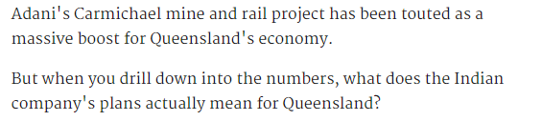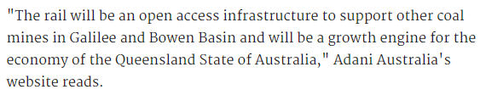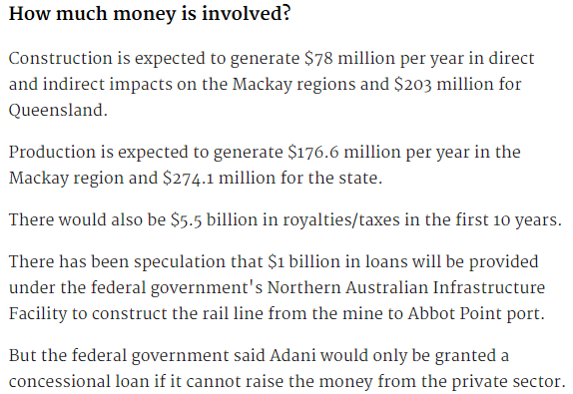

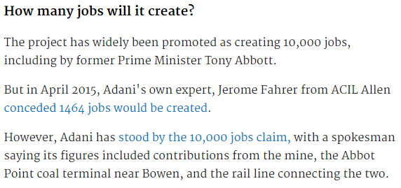

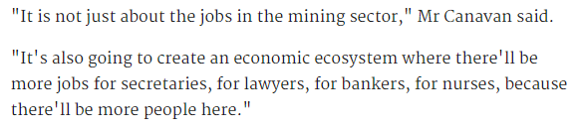

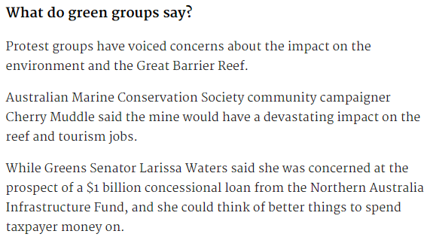

<http://www.smh.com.au/business/mining-and-resources/adani-carmichael-mine-drilling-into-the-numbers-for-queensland-20161206-gt4t8n.html>

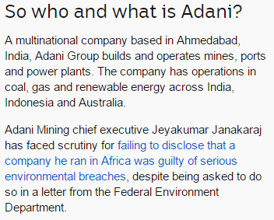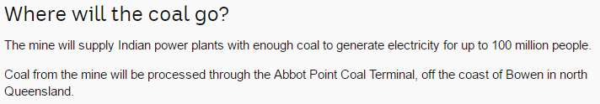

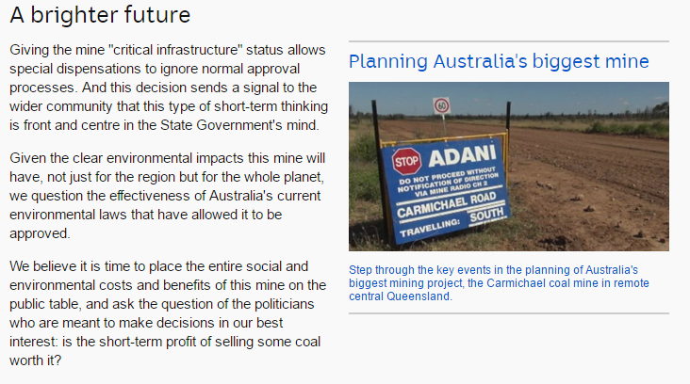<http://www.abc.net.au/news/2016-12-05/what-we-know-about-adani-and-the-carmichael-mine-project/8094244>

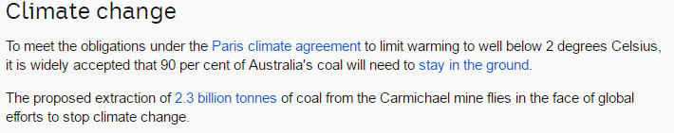

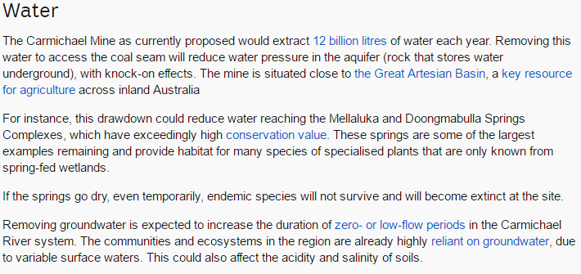

<http://www.abc.net.au/news/2016-11-02/fast-tracking-adani-carmichael-coal-mine-a-bad-idea/7988116>